

**ECEN 5053-003 Homework Assignment**

Course Name: Embedding Sensors and Actuators

Corresponding Module: C1M3

Week Number: 3

Module Name: Rotary Sensors

Submitted by: Poorn Mehta

**Problem A**: A spool cutting machine with spool diameter of 0.25 meters cuts a piece of fabric 7 meters long. How many revolutions would the absolute encoder measure?

Solution: **8.917**

A spool cutting machine has a roller mechanism, which is used with encoder to cut the fabric with very high accuracy. A single revolution of the roller would convert into the linear distance which will be equivalent to its perimeter. Therefore, for multiple revolutions: L = 2*π*R*N; where L denotes Length, R is Radius, and N is number of Revolutions. Modifying for N; we have N = L / (π*2*R) = 7 / (3.14*0.25) = 8.917.

1. **Problem B**: An absolute encoder is mounted to the motor driving the X-axis lead screw of a CNC milling machine. If the encoder has a spec of 1500 PPR, a lead of 1 mm, and the lead screw moves a distance of 200 mm, how many revolutions of the lead screw will the encoder count and what is the resolution of the X-axis?

Solution: **200 Revolutions, X-axis Resolution of** **0.67µm**

Lead is the distance travelled by screw in linear direction per revolution. Therefore, distance D = L * R, where L is the lead and R is the number of revolutions. Plugging in given values, we have R = 200 / 1 = 200. The resolution is defined as the minimum distance that can be measured by the encoder. It is simply the ration of lead to pulse per revolution (PPR). Therefore, Resolution = L / PPR. Plugging in given values, we have Resolution = 1 / 1500 = 0.67µm.

**Problem C**: An encoder has an input voltage of 24 volts and a transformation ratio of 0.475. What is the output voltage in volts?

Solution: **11.4V (At Maximum Magnetic Coupling Position)**

The presented case is of a resolver. Resolver is basically a specialized transformer whose output voltage depends on the angular position of the shaft. Transformation ratio is nothing but the ratio of output voltage to the input voltage, but at the maximum magnetic coupling position [**[3]**](https://www.dynapar.com/knowledge/resolver-output/) . Therefore, just with the knowledge of input voltage and transformation ratio, the output voltage can’t be determined. However, assuming that the shaft is at a position which is generating the maximum magnetic coupling, then Vout = T.R. * Vin. This will result in Vout = (0.475 * 24) = 11.4V.

**Problem D**: Your resolver has a maximum tracking rate of 26 revolutions per second (rps) and gives rotational accuracy of 12 arc minutes. If you need a rotational accuracy of 0.25 degrees and your motor shaft rotates at 1750 rpm, can you use your resolver? Why or why not?

Solution: **No (Unless resolver can operate at speed higher than maximum tracking rate).**

Resolver is having the maximum tracking rate of 26 Revolutions per Second, therefore (26 * 60) = 1560 Revolutions per Minute. Clearly it is lesser than the required – 1750 Revolutions per Minute. Therefore, the given resolver cannot be used directly for the presented application. This is by the assumption that a resolver must not be operated at speed more than the maximum tracking rate. If however, it is possible to operate it at higher speeds, by simply compromising in the accuracy linearly – making calculations (1750/1560) * 12, accuracy = 13.4615 Arc Minutes. Now 1arc minute = 1/60° [**[4]**](http://coolcosmos.ipac.caltech.edu/cosmic_classroom/cosmic_reference/angular.html) . So, 13.4615 arc min = 0.224°. So, this resolver is satisfying the sensitivity criteria when rotating at given speed.

**Problem E**: A two-channel encoder counts the leading and trailing edges of the pulse trains of its two channels. Suppose the resolution of a single channel encoder is 400 PPR. If you add a second channel to the encoder, and change no other specs, how much can you improve the resolution of the encoder?

Solution: **4 Times or 2 Times**

Since it is not clear whether the given single channel encoder resolution (400 PPR) is the value taken when (1) The encoder is only counting rising (or falling) edge of the signal, or (2) The encoder is already counting at both – rising and falling edge of the signal. For the case (1) the addition of second similar channel, and the feature of counting at both edges – rising and falling, would result in the resolution rising to 4 times the original (1600 PPR now); however for the case (2) the addition of second channel would bring only 100% increase in resolution, effectively doubling the original resolution (800 PPR now) [**[5]**](https://www.dynapar.com/technology/encoder_basics/quadrature_encoder/) .

**Problem F:** A multiple speed resolver has 16 sets of secondary windings. Relative to a single speed resolver of the same basic design, how many times more accurate will it be?

Solution: **8 Times**

In a single speed resolver, there are two sets (1 pair) of secondary windings, both being physically located at right angle of each other. This will result in them generating one complete Sine Wave and one complete Cosine Wave for one complete Revolution [**[6]**](https://www.dynapar.com/knowledge/resolver-speed-accuracy/) . Therefore 16 sets will result in 8 Sine and Cosine waves (16 sets make 8 pairs) being generated per one complete Revolution [**[7 – page 20]**](http://www.moog.com/literature/MCG/synchrohbook.pdf) . Therefore, it will be 8 times more accurate than a single speed resolver with the same basic design.

**Problem G**:Explain how a resolver determines angular position.

Solution:

The resolver uses various arrangements to create multiple inductors – in form of stators and rotor. The primary stator is energized with AC signal from a power source. Since the rotor is also an inductor, it will have moving/dynamic inductive coupling with the stator. This will cause other two stators (secondary ones) from which the outputs are taken, will induce varying voltages. Notably, these two secondary stators are placed at right angle from each other, so that they will have the phase difference of 90° between their output signals. Now as the input is sinusoidal, the outputs will be retaining the same shape of waveform. During one full revolution, the output sine and cosine wave will have unique values. As the output electrical signal is a function of rotor position, the resolver can determine angular position accurately [**[8]**](https://www.zettlex.com/how-does-a-resolver-work/).

**Problem H:** What is the transformation ratio for a resolver? What aspects of the resolver determine this ratio?

Solution:

The transformation ratio of a resolver is the ratio of its output voltage to input voltage when the output voltage is at the maximum magnetic coupling [**[9]**](https://www.dynapar.com/knowledge/resolver-output/) . Now as it includes the condition of maximum magnetic coupling, which is occurring due to the mutual inductance between inductors, everything that affects the inductive coupling of two or more inductors, has the influence over the transformer ratio too. Resultantly, the aspects that determine the transformation ratio are: material specific permeability, number of windings in each inductor, cross sectional area of the inductor, and the length of the inductor [**[10]**](https://www.electronics-tutorials.ws/inductor/mutual-inductance.html) .

**Problem I**:What are the four impedances that a resolver exhibit? How are these impedances represented in a resolver?

Solution:

Resolver falls under the category of a family of devices collectively known by their generic name synchro devices [**[11]**](https://www.pantechsolutions.net/control-systems-tutorials/synchro-transmitter-and-receiver-tutorials)**.** Now all synchro devices have 4 impedances as per following:

**ZPO**: Primary Impedance, Secondary Open Circuit

**ZPS**: Primary Impedance, Secondary Short Circuit

**ZSO**: Secondary Impedance, Primary Open Circuit

**ZSS**: Secondary Impedance, Primary Short Circuit

For resolver, the terms Primary and Secondary are replaced by Rotor and Stator, respectively. Therefore, for a resolver, these impedances will become as per the following [**[12 – page 6]**](http://www.icpe.ro/messico/technical_data_sheet/Resolvers.pdf) :

**ZRO**: Rotor winding impedance (primary), with the no-load secondary windings

**ZRS**: Rotor winding impedance (primary), with the other short-circuit

windings

**ZSO**: Sine winding impedance (secondary), with the other no-load

windings

**ZSS**: Sine winding impedance (secondary), with the other short-circuit windings

These impedances play an important role for many applications and characteristics for the resolver. For example, when compared with a standard unit, the brushless resolver will have lower impedance angle, which will affect power consumption, phase shift, and torque gradient of the device. Input impedance of the resolver is a crucial parameter to look at, when designing a system based on it [**[13]**](http://www.analog.com/en/analog-dialogue/articles/precision-rtdc-measures-angular-position-and-velocity.html) . Frequency response is also dependent on the impedance; as well as loading effect on resolvers can be determined with an equivalent T network, based on impedances, as per the following [**[14 – page p5]**](http://www.moog.com/literature/MCG/synchrohbook.pdf) :

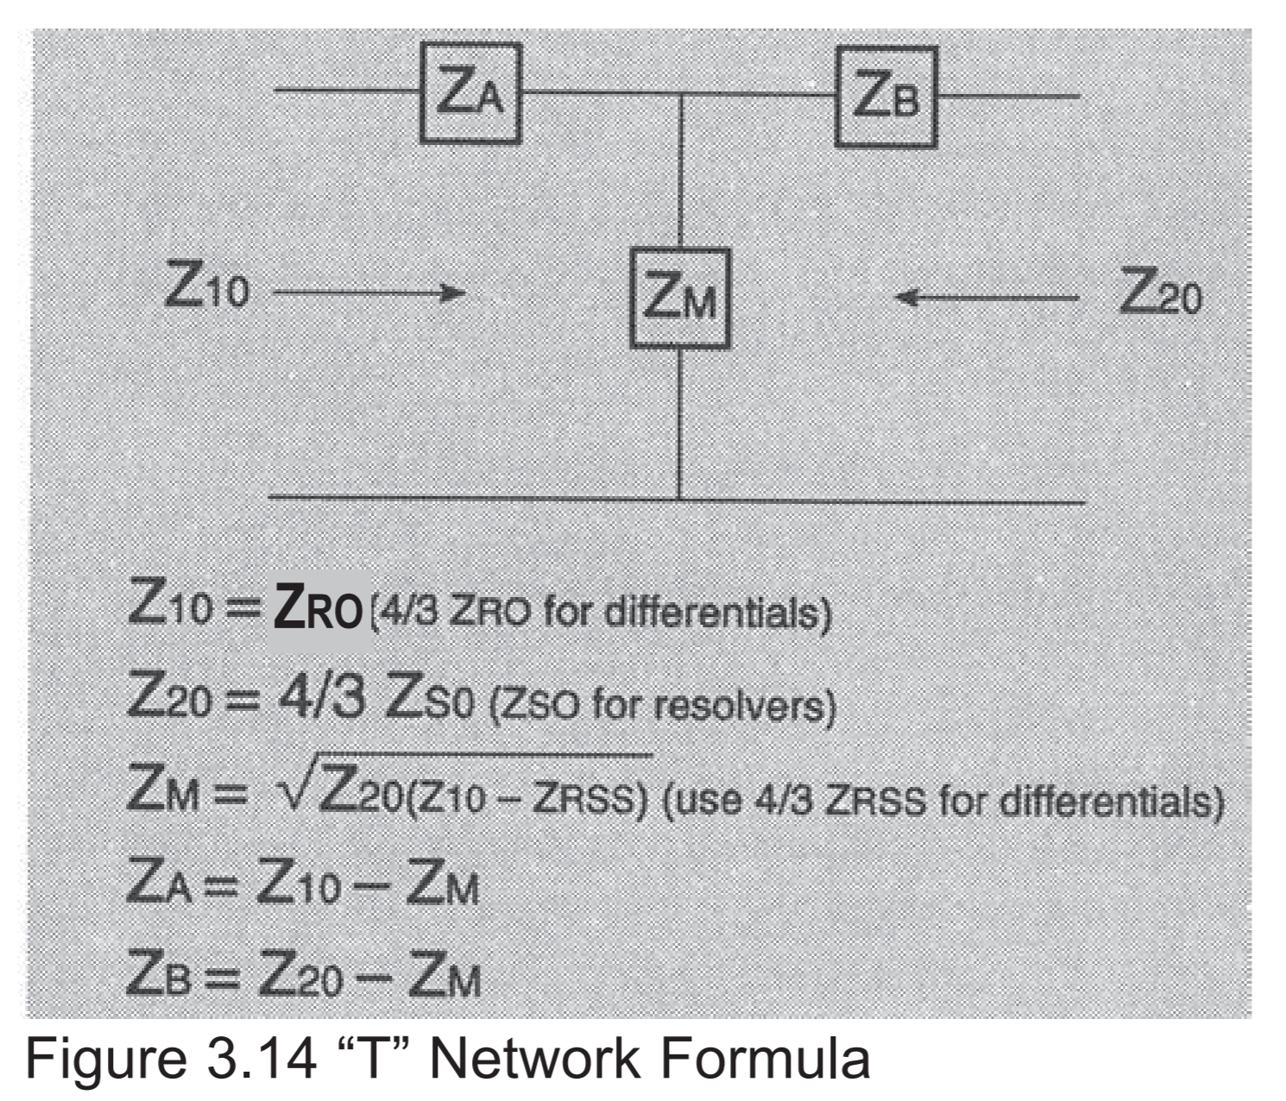

It should be noted that with the change in the resistance of copper magnet wire, the impedance varies, using which – some of the conditions can be explained or resolved [**[15]**](http://www.moog.com/literature/MCG/synchrohbook.pdf) . There are many other properties and characteristics which are dependent on the resolver impedances.

**Problem J:** Why is an encoder’s performance stated in terms of resolution, as opposed to accuracy? How does the repeatability of the encoder compare to its resolution?

Solution:

Resolution is the smallest physical movement measurable. It is defined as the distance of a single count. For rotary encoders resolution values are measured in counts/revolution. On the other hand, accuracy is the difference between the actual “true” position of the motion axis and the position as reported by the encoder read head. Measuring accuracy requires a very accurate measurement standard such as a laser interferometer. Now the primary application area of encoders is the motion control systems. To integrate encoders in a way that it serves the purpose, there are a few things which needed to be taken care of, especially when using a high-resolution encoder. A primary consideration is that motion controller and servo drive encoder inputs have a maximum frequency that can be supported on their encoder inputs. If accuracy is kept as the primary factor for the performance of the encoders, then it could be the case that the considerations arising due to the resolution might get overlooked by the system developer and on a later stage, create issues. To prevent that, the resolution is used as the primary aspect to measure the performance of an encoder, as it is having simply more importance during the actual application [**[16 – page 2]**](https://www.celeramotion.com/sites/default/files/TN-1005_Resolution_Accuracy_%20and_Repeatability.pdf) . Also, a motion control system is likely to dither between two counts; and thus, the magnitude of dither will be reduced when a higher resolution encoder is selected. Therefore, the system accuracy is dependent on and limited by the resolution of the encoder [**[17]**](https://www.azosensors.com/article.aspx?ArticleID=723) .

Repeatability is a measure of how consistently the system can return to the same commanded position. For encoders, repeatability typically would be 2-10 times better than accuracy [**[18]**](https://www.dynapar.com/knowledge/encoder_resolution_encoder_accuracy_repeatability/) . In other words, repeatability is the total range of positions attained when the system is commanded to one location, multiple times, under all conditions. Generally, the repeatability is specified as ± (resolution) [**[19 – page 5]**](https://www.celeramotion.com/sites/default/files/TN-1005_Resolution_Accuracy_%20and_Repeatability.pdf) .